Manchester City Council Tackles Gambling Harms with Revised Policy and Staff Safety Measures

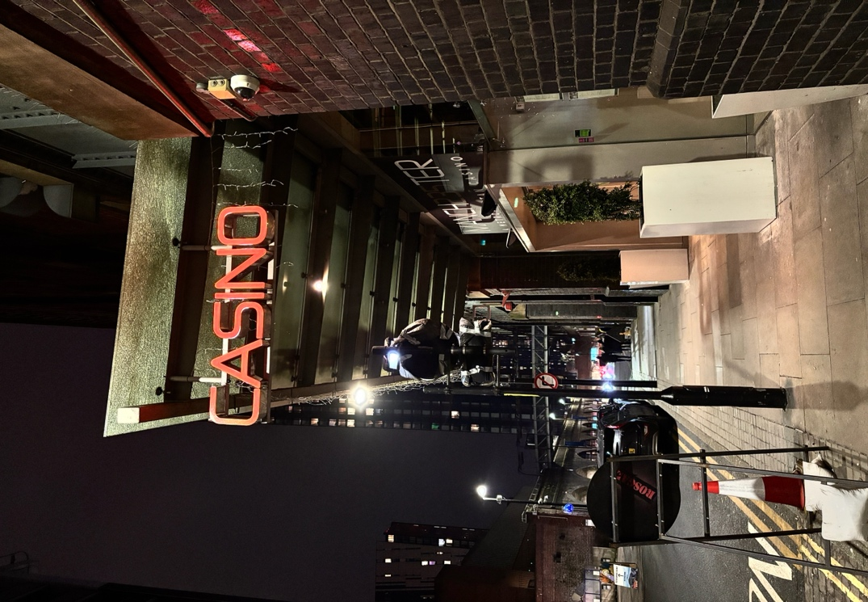
Questions surrounding the regulation of gambling in Manchester were a central focus during the Manchester City Council’s Licensing Policy Committee held on November eighth, 2024.

The committee convened to discuss the proposed final revision of the Council’s Statement of Principles for Gambling for the period of 2025-28, a document mandated by the Gambling Act that outlines how the Council will implement its requirements.

The meeting was chaired by Councillor Grimshaw and attended by Councillors Davies, Evans and Connolly.

The Licensing Manager introduced the report, emphasising that the Council is required to produce a Gambling Policy every three years, with the next version set to take effect in January 2025.

This revision includes minor updates in anticipation of forthcoming guidance from the Gambling Commission.
Manchester235 Casino

Key Updates in the Draft Policy

The draft policy has been changed to incorporate references to the Greater Manchester Gambling Harms – Strategic Needs Assessment and now needs supporting documentation for premises gambling machine permit applications.

The committee reviewed responses from a public consultation that had engaged various interested parties including residents and gambling operators.

Staff safety in licensed gambling establishments was a topic of debate after Councillor Grimshaw opened the floor to questions. One committee member expressed worries about the possible dangers of employees working alone after hours.

The Licensing Manager responded that licensed operators are encouraged to join the ‘Safebet Alliance’, which focuses on improving safety measures for staff and counteracting criminal activity within gambling premises.

Concerns Over Staff Safety

Making sure that employees are fairly represented in the Safebet Alliance was a major topic of conversation. One committee member questioned if representatives of gambling establishments actually represent the interests of workers who work extra hours or work alone.

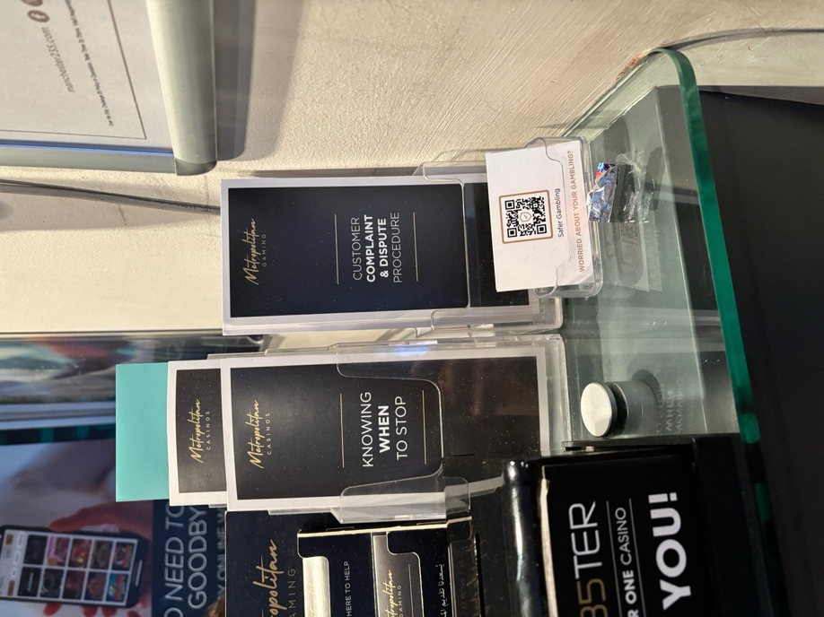
In an interview with Dom Jacobs, a staff member at Manchester235 he shared his perspective on the challenges faced by employees in the industry:

“As a staff member in this gambling shop, I see firsthand the impact of our industry on the community. While we strive to provide a safe and enjoyable environment for our customers, the concerns about gambling addiction and safety are always at the forefront of our minds. The recent discussions around staff safety measures are crucial; we need to feel secure while doing our jobs, especially during late hours.”

He went on to explain that in his workplace he feels safe as they have strict security, but he stated that smaller casinos, located in more central areas, such as Admiral near Piccadilly Gardens will likely face higher risk of staff abuse.
Help Leaflets / Manchester235

When asked about their role in gambling related harms, he pointed to the gambling leaflets and stated, “We regularly check up on our customers and provide them with information about support services like ‘Sense’, which is the voluntary Self-Enrolment National Self-Exclusion scheme. It’s vital we signpost people to resources that can help them if they’re struggling with gambling issues.”

In order to guarantee improved representation, the Licensing Manager agreed to bring up this issue with the Safebet Alliance. Subject to any last-minute changes the committee deem necessary, the committee unanimously decided to recommend that the Council adopt the updates Gambling Policy for publication.

This ruling demonstrates a larger commitment to address community concerns regarding gambling-related harms, in addition to adhering to legal requirements.

Community Engagement and Public Sentiment

The meeting highlighted a growing public opinion concerning Manchester’s gambling regulations. Locals have voiced concerns about the effects of gambling on their communities, especially in relation to addiction and criminality associated with gambling venues.

The goal of the consultation process was to get a range of viewpoints from different groups, such as community organisation and health professionals. In order to develop policies that represent the demands of the people, Councillor Evans underlined the importance of community interaction. He said, “We need to ensure that our policies are not only compliant but also serve our community effectively.”

Future Challenges and Initiatives

Implementing practical strategies to lessen the negative effectives of gambling is still difficult, notwithstanding the progress made during the meeting. The committee acknowledged that although regulatory frameworks are necessary, support services for individuals impacted by gambling addiction must also be provided.

One issue highlighted during the discussion was the lack of access to counselling and rehabilitation programs in many areas. Councillor Connolly proposed that educational campaigns may be a key component in raising awareness about responsible gambling practices among residents. “We need to inform people about the risks associated with gambling and what support services are available,” he said.

Next Steps for Policy Implementation

The Licensing Policy Committee intends to continue discussing this subject at future meetings. The updated policy must be finalised, and more measures to improve community safety around gambling establishments must be investigated.

Despite the fact that the Licensing Policy Committee of Manchester City Council has made great progress in revising its Gambling Policy, there are still ongoing challenges related to community safety and staff welfare in gambling venues.

As these conversations progress, the commitment to engage with stakeholders and addressing public concerns will be vital as these discussions continue.

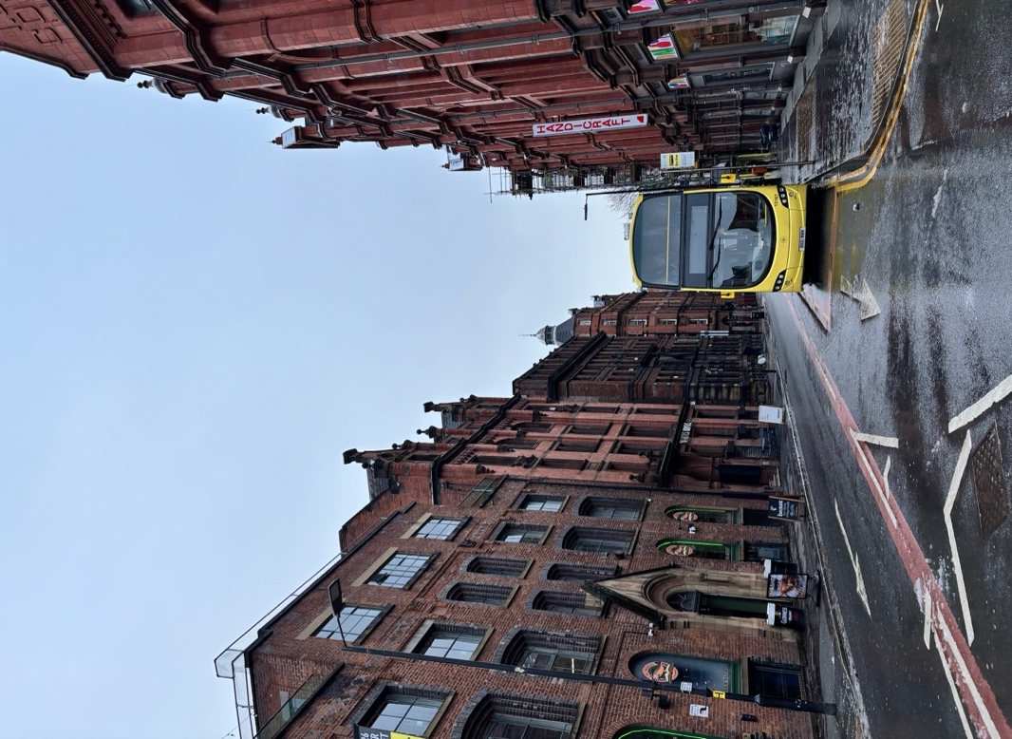
The Bee Network: What Does Public Ownership Mean for Greater Manchester?

Starting January fifth, 2025, the remaining 250+ buses and trams in Greater Manchester will transition to public ownership under the Bee Network.

The significant changes made by The Greater Manchester Combined Authority (GMCA) aim to create a “high quality, affordable, and fully
integrated public transport and active travel system for the people and businesses of Greater Manchester.” According to their website.

This initiative is not only about improving public transport but also about cultivating sustainable economic growth across the region.
Bus stop / 37 Lever St

Key Features of the Bee Network

Affordable and Integrated Ticketing Systems

The integrated ticket purchasing system is designed to simplify travel for residents, making it easier for them to access public transport without financial difficulties.

According to research by Transport for Greater Manchester (TfGM), an integrated ticketing system can significantly increase public transport usage by making it more convenient for users to navigate the network. The goal of the program is to encourage more people to take buses and trams by reducing travel costs.

Fare Reductions
Fare reductions will make public transport more accessible, particularly for families and low-income individuals:
- 7-day Bus Travel: Reduced from £21 Adult/£10.50 Child to £20 Adult/£10 Child.
- 28-day Bus Travel: Reduced from £85.40 Adult/£42.70 Child to £80 Adult/£40 Child.
Introduction of Pay-As-You-Go (PAYG) System

The implementation of a pay-as-you-go system will greatly improve the user experience. Similar to Transport for London’s (TfL) successful model, this technology enables users to tap on and off, utilising contactless payment methods.

Among the financial benefits are:

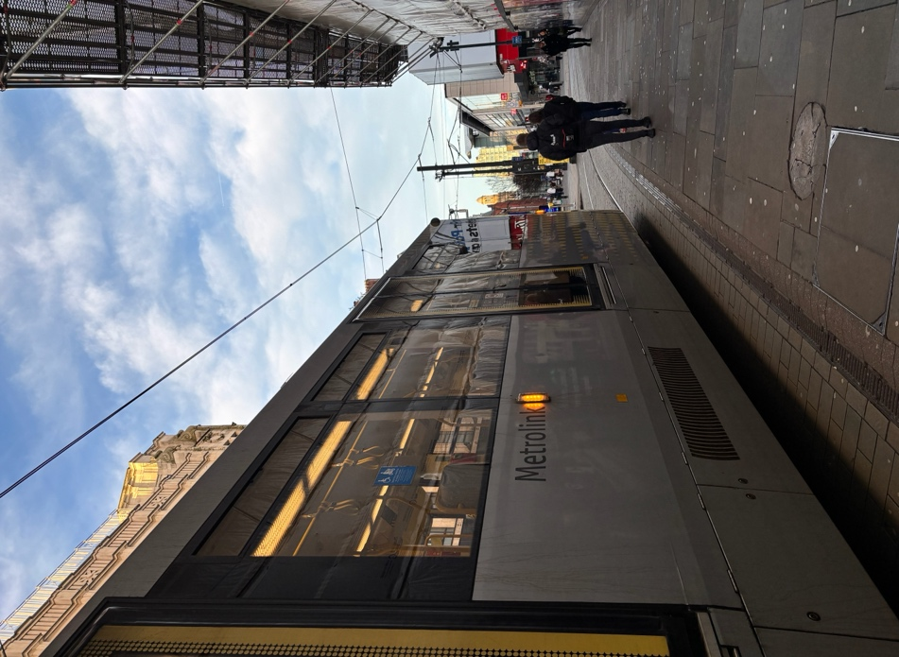
- Decreased Cash Handling: Keeping cash transactions to a minimum reduces the costs of handling and transferring cash.

- Reduced Infrastructure Needs: Maintenance expenses are decreased when traditional ticket vending machines are used less frequently.

- Shared Model Platforms: In order to drastically reduce operating expenses, several transportation agencies are implementing shared platforms for fare collection.

Tram stop / Piccadilly Gardens

Andrew Griffin, a former bus driver and now a mobile performance supervisor at the Bee Network, shared his thoughts on the recent changes:

“There have been mixed feelings about this transition; some people are mistakenly attributing late buses during peak hours to these changes.”

He expressed optimism about the new technology: “Things will be a lot better with the tap-and-go systems when it is fully implemented. You can still pay with physical money; it’s just more streamlined now and gets buses moving faster.”

Griffin also praised the new fare options: “I think the new £2 bus hopper ticket is fantastic as you can get on and off as many times as you want in 60 minutes.”

However, he notes challenges in public awareness: “Despite these advancements, many passengers remain confused about the new Bee Network changes. It needs to be advertised to the public more on billboards and leaflets; currently, the information is only on the Bee Network app, which is a bit frustrating.” Overall, however, he viewed the shift as positive for Manchester and saw it as an achievement, akin to London’s transport systems.

Initiatives for Active Travel

As part of the Bee Network’s larger transport plan, active travel initiatives such as the UK’s largest cycling and walking network are now being prioritised alongside enhancements to public transport.

Infrastructure for walking and bicycling has been improved throughout Greater Manchester with funding from a variety of sources, including government subsidies. By improving the infrastructure for walking and cycling, this initiative aims to encourage more locals to adopt active transportation.

According to a report by GMCA, active travel accounted for around 33% of all trips made by Greater Manchester residents in 2023. This statistic highlights a growing trend in the strategy towards healthier and cleaner commuting options and highlights the importance of integrating active travel.

Environmental Benefits

The environmental benefits anticipated from the Bee Network’s improvements and the transfer to public ownership include:

- Increased Electric Bus Usage: electric bus usage has grown dramatically; by 2025, over 20% of buses are expected to be electric, up from the current 10%. This evolution aligns with Greater Manchester’s vow to reduce carbon emissions and promote sustainable transport solutions.

Research suggests that electric buses produce significantly lower emissions compared to traditional diesel buses, contributing positively to air quality improvements in urban areas. The GMCA’s focus on sustainability is further emphasised through its commitment to reducing carbon emissions as part of its broader environmental strategy.

Economic Impact

The Bee Network has significant economic ramifications. Jobs in a number of industries linked to public transport operations are projected to be created by the shift to public ownership. For example, bus companies have already committed to workforce development in the area by hiring a large number of apprentices.

Additionally, bus service revenue has increased along with patronage. This was demonstrated in recent record-breaking data from the sixth of September 2024 when over 305,000 journeys were recorded.
Revenues as of October 2024, according to the GMCA, surpassed £20 million in Tranche 1 areas alone, a £3 million higher than budgeted. This financial achievement lessens the overall economic strain that the transportation industry is under as a result of growing operating expenses and the outstanding impacts of the pandemic.

Local Sentiment

Involving the local community is essential to the Bee Network’s success. Understanding local requirements and preferences with regard to public transport services will involve public discussions and feedback systems.

Alistair Cannon, a 26-year-old mechanical engineer, living in the Northern Quarter, uses the Bee Network regularly. He shared his thoughts on the fare reductions:

“Although the reductions don’t seem dramatic, whilst everything in life seems to be going up with inflation, it’s good to see that the mayor and council of Manchester are prioritising public transport. I believe that good public transport links are key for a thriving economy and increasing equality by mobilising those less financially fortunate.”

He also expressed his hopes for future developments:

“I would like to see an expansion of the tram network, the Bee Network to link with the rail network, and the buses being 100% electric, which I know is a targeted aim for 2026.

When asked about the active travel infrastructure he noted:

“I don’t cycle in the city myself, however I have noted the Manchester cycle system seems to be well organised and definitely a lot safer than comparable cycling systems in other systems. Most my journeys are performed on foot, and I find it a very easy and safe system to use - in particular, there are a large number of crossing points that are clear and simple to use, even with busy roads I find Manchester accessible as a pedestrian. I would like to note the pollution on the other hand is less comfortable. Because I live in the city centre I am very aware of the thick diesel fumes.”

As these changes take effect in early 2025, they will likely have lasting impacts on accessibility and sustainability within the region.

Greater Manchester is taking steps in building a strong public transport system that serves the requirements of its varied population by placing a high priority on affordability and community involvement.

