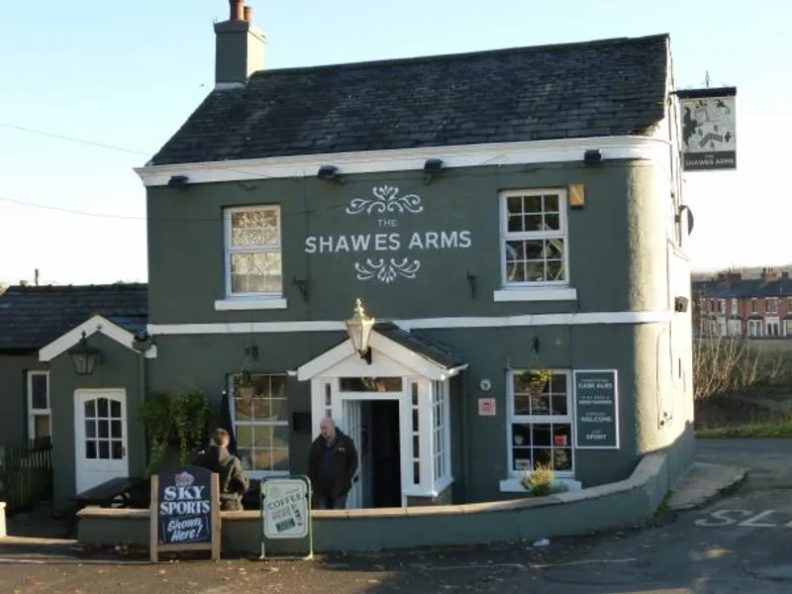
A man was found dead in Irlam early this morning after being stabbed.

The victim, 25-year-old Peter Cope, was attacked while walking home from a nightclub.

The incident occurred at around 3 AM on Roslyn Street, near the Shawes Arms pub, Cope had left Peking Pete’s nightclub shortly before the attack and chose to walk the two miles home alone, while his friends opted for a taxi.

Eyewitnesses reported seeing at least three men involved in the assault, which police believe was unprovoked and shocking in nature.
The Shawes Arms / Credit: CAMRA
Superintendent Neal Smythson of Greater Manchester Police confirmed that two men, aged 24 and 22, were arrested shortly after the incident but were released without charge.

Authorities are still investigating the motive behind the attack and have not recovered the weapon used.

Forensic experts indicate that Cope sustained three stab wounds, with the fatal injury inflicted to his chest, believed to be caused by a knife with a blade of at least six inches.

Martina Kopic, Cope’s mother, expressed her devastation in a heartfelt statement: “I am devasted by his death. He was a young man with his life ahead of him and I can’t understand how this could have happened.” She described her son as a quiet and helpful person who avoided trouble and had no connections to drugs or gangs.

Cope, originally named Petar Kopic, emigrated from Bosnia as a child during the Balkan War. His family sought asylum in the UK and were granted permission to remain.

Known for his dedication to his job at Premier Cleaning Services, where he maintained the Greater Manchester Police Station’s custody suite, Cope was well-liked by colleagues who appreciated his hard work.

Police urge anyone with information about the incident to come forward to assist in their ongoing investigation. The community is left mourning a life cut tragically short, highlighting the urgent need for safety and justice.

Follow Up Stories:
Community Response to Violence

Angle: Explore how local residents are reacting to the stabbing and what measures they believe should be taken to improve safety in Irlam.

Potential Interviewees:
- Residents
- Community leaders
- Neighbourhood watch representatives
- Local councillors

Support for Victims’ Families

Angle: Investigate if enough resources are available for families affected by violent crime in Greater Manchester, including support groups and counselling services.

Potential Interviewees:
- Representatives from victim support organisations
- Mental health professionals
- Families of previous victims of violence

Every winter, the Manchester Christmas Markets light up the city, attracting millions of visitors to the 240 stalls spread out around the city.


Now in their 26th year, they bring undeniable vibrancy to Manchester, but their impact on local shop trade is a topic of mixed opinion.

Do these markets provide a much-needed boost to local businesses during the holiday season, or do they create competition that leaves some shops struggling to keep up? The answer depends on who you ask.

The Manchester City Council estimates that this year’s 2024 markets will attract about nine million visitors, making them one of the largest in Europe.

For local businesses, this influx of people presents an opportunity to increase sales and showcase their
products and services to a wider audience, that may not usually be in the area.
New Cathedral Street Christmas Markets

Market stallholders also report positive outcomes. Many see the event as an opportunity to build a new customer base in prime locations around the city such as Albert Square and St Ann’s Square.

Dom Loftus, 23, whose family owns Java Bar Espresso, a stall on New Cathedral Street, said that his time at the markets this year has been “successful” and “done what we needed it to do”.
Dom Loftus (right) and Lara Campbell / Java Bar Espresso

On the other hand, logistical issues caused by the markets, such as crowded streets, can deter regular customers from visiting city-centre stores.

Lara Campbell, 21, from the same stall added that locals “avoid the shops near the markets”.

Conversely, she says that people from outside of Manchester visiting the markets will ultimately bring new trade to the shops.

Some local shops feel that the markets create challenges for their trade. With hundreds of stalls offering everything from festive foods to artisanal gifts it’s natural that some of the local shops will fear competition this Christmas.

From an official standpoint, Manchester City Council representative Pat Karney emphasised his belief in the overall economic benefits of the Christmas Markets when speaking to ‘I Love Manchester’ he claimed, “All the cafes, shops, and restaurants support the markets—they’re not in competition with them.”

Laura Farrell, 35, the manager of the clothing store Reiss on New Cathedral Street expressed her views on trade during the markets: “The markets potentially hinder increased footfall but not for ‘our’ customer. Blocked streets and general congestion make for a social offering but not a purposeful shopping clientele.”

She noted that while weekends tend to be more fruitful for sales, midweek sales were negatively affected. “The shopfront was not visible from the main street for the entirety of the time. Meaning it was only regular/familiar customers who knew how to reach us.”

Farrell also pointed out that while footfall increases during weekends, mostly because many customers are also visiting the markets, the shopping experience becomes blurred due to distractions like nearby bars. “With a bar just outside the store, footfall was drinkers not shoppers,” she clarified.

Logistical challenges were noted as well: “Deliveries often couldn’t come through and access routes were blocked.”. She explained that they adapted to this by changing the routes, but said “It’s tiresome for staff who cannot have a normal routine”.

After another year of Christmas markets, the complex conversation around the impact on local business’s trade remains.

While some shops thrive amid the bustling atmosphere, others face difficulties that require them to either adapt or lose out on trade.

Follow Up Stories:

Post-Market Economic Impact Analysis

Angle: Examine the actual sales data from local shops after the Christmas Markets to assess their economic impact.

Potential Interviewees:
- Local shop owners
- Manchester City Council economic analysts
- Business association representative

Comparative Study with Different Events in the City Centre

Angle: Analyse how Manchester’s Christmas Markets compare with similar events in Manchester’s city centre in terms of encouraging in trade.

Potential Interviewees:
- Shops that have experienced other events in the city affecting their trade
- Council representatives
- Economic experts

https://www.manchester.gov.uk/news/article/9602/the_million-pound_boost_for_manchester_community_groups_tackling_the_cost-of-living_crisis

Manchester City Council has launched a significant funding initiative to support community groups addressing the cost-of-living crisis. At the beginning of this year the initiative aimed to distribute over £1 million in grants to local organisations.

The funding is designed to assist nearly 100 community groups across Manchester. Each receives up to £15,000 for smaller projects and £30,000 for partnerships.

In a city where many residents are struggling, the Council’s initiative comes at an urgent time.

The cost-of-living crisis has severely impacted Manchester’s communities, leading to increased demands for food banks, mental health support, and educational programs.

This financial boost will enable these groups to enhance their support services for residents grappling with the challenges posed by rising living costs.

Local authorities have been urged to ensure that the funding reaches those most in need and that it fosters long-term resilience rather than temporary relief.

Upon requesting a Freedom of Information (FOI) inquiry regarding this funding initiative, it was revealed that a total of £1,157,364.62 has been awarded to the 82 groups.

This includes an additional £157,324.62 provided by the Our Manchester Food Partnership for groups that submitted strong applications focused on cost-of-living activities with a food focus.

Councillor Joanna Midgley emphasised the importance of community involvement, “What we have seen here is that if given the opportunity there can and will be a tremendous local response to the issues we collectively face. This funding will have been a lifeline for so many people and as we approach Christmas, I am incredibly proud on how this money has been spent, and the real-world benefits this will have resulted in.”.

Examples of how the funds were allocated and spent by the council:

- 422 Community Hub (Manchester Vineyard) received £15,000 to ensure paid staff time for impactful projects directly affecting local lives.

- African Rainbow Family, also awarded £15,000, aims to help siblings integrate into British society while covering core operational costs.

- Age UK Manchester secured £13,818 to support socially isolated older individuals’ post-hospital discharge.

- Yes Manchester CIO was awarded £15,000. Yes is an award-winning Manchester charity helping unemployed and under-employed residents access employment, volunteering and learning opportunities. Operating from two offices in high- deprivation areas, they provide free digital workstations, coaching and comprehensive employment support services.


Their vision is to “build confidence, drive ambition and inspire people to be the best they can be”.

Currently facing funding challenges with an 8-month waiting list they were awarded £7,900 of a £75,000 UKSPF application and secured the £15,000 to retain staff, ensuring continued support for Manchester residents seeking to improve their employment prospects.

Tim O’Neill operations manager at Yes Manchester said regarding the cost-of-living crisis, “Rising prices for essentials such as food, housing, and utilities are placing immense pressure on households, especially those on low or fixed incomes, leaving many families forced to choose between heating their homes and putting food on the table. For our charity, these pressures have resulted in a surge in demand for our services, straining our limited resources and leading to extended waiting lists as demand continues to rise.”

When discussing the grant’s impact, he emphasised, “The £15,000 grant from Manchester City Council has been invaluable in helping us tackle the growing challenges brought about by the cost-of-living crisis. This funding has allowed us to extend the contracts of essential key workers, reducing waiting times for our services and ensuring timely, targeted support for those in need. It has enabled us to continue empowering disadvantaged individuals to overcome barriers and achieve meaningful, sustainable employment, ultimately helping us to combat the crisis, and meet the ever-growing demand for our services.”
Yes / Newton Health

While the initiative has received praise for its timely response, some critics may argue that more comprehensive measures are needed to address the root causes of economic hardship.

Follow Up Stories:

Impact of Cost-of-Living on Community Services
Angle: Examine how the cost-of-living crisis has directly impacted multiple community services and the residents they serve.

Potential Interviewees:
- Representatives from funded community groups
- The residents that benefit from these services
- Manchester City Council representatives

Success Stories from Funded Organisations
Angle: Further specific success stories from community groups that received funding and how they have used it to tackle the cost-of-living crisis.

Potential Interviewees:
- Leaders of successful community organisations
- Specific councillors involved in the initiative
- Participants in programs funded by the initiative

Manchester has been named the second most unaffordable place to rent in the UK, exceeded only by the London borough Kensington and Chelsea.

According to the latest 2022/2023 analysis from the Office for National Statistics, renters in Manchester now spend an average of 45.6%, nearly half of their household income on rent, a significant rise from 37.1% in 2019/20.

This contrasts with the 34.2% U.K average of income in England spent on the average priced rental home at the end 2023’s financial year.

Wayne Allan / Greengate HJ Salford
With the rental market under pressure and many households feeling the pinch, the situation has sparked debate about the cost of living.

To better understand local sentiment, we spoke to several of Manchester’s residents.

Wayne Allan, aged 41, a labourer, from Northeast England living in Salford highlighted the extreme prices of a high-rise buildings he was building, the penthouse apartment at Greengate HJ, Salford: “The prices are absolutely ridiculous, it’s £8,000 a month, who can afford £8,000 a month? You may as well get a mortgage!”

According to Wayne, starting prices are £1,500 a month for a 1-bedroom apartment – and “there’s nothing really to the apartments.”

Glesni Blandford, aged 21, an auditor for PWC, from Withington and her colleague Eve Moore, aged 21, from Greengate, shared their frustrations regarding renting as graduates.

Glesni was in student accommodation in Leeds but now lives in a rental in one of Manchester’s student territories, which she described as “small with mould and damp”.

She added, “I get by, but I’m probably still living paycheck to paycheck because of paying for rent.”

Eve continued, “We’re in good jobs, so for us to be using forty percent of our paycheck means obviously people on minimum wage wouldn’t have a chance.”


Grace Bayley, aged 23, an investment administrator from Whitworth reflected on her own experiences moving here around three years ago: “Manchester is not cheap, I rented a flat by myself (near Victoria station), a little one bed, and it was £750 a month, that flat now goes for over £1,000 a month.

Explaining that she moved back in with her partners parents to combat this she said, “We bought a house and stopped renting after 2021, I don’t think renting is attainable for a sole person anymore.”

Eric Chen, aged 26, a NatWest banker, from Beijing lived in Whitechapel in London for 3 years, he called the rent “extremely high” then he moved to a 1-bedroom flat in Manchester’s Deansgate Towers (Castle Wharf) for £2,000 a month approximately with bills – “it’s cheaper than London, but still very expensive”.

He said he shares with other young professionals now for around £1,000 instead, he expressed that he couldn’t survive without financial aid from his parents.
Eric Chen / Deansgate

Brittany Smith, aged 25, a barrister’s clerk at 18 St. Johns Street from Haywood described living with her parents after travelling from Australia and trying to move out with her boyfriend, “It is ridiculous. its extortionate compared to what you get paid nowadays, I don’t know how people are meant to live. I wanted to come back and move out, but it’s like oh my god, it’s actually near impossible.”

Camila Fernandes, aged 36, a waitress from living in Salford reflected on the rising costs since moving from Brazil 5 years ago “I could save more money at the end of the month; the prices were more affordable. Nowadays it’s getting really expensive like London.”

Follow Up Stories:
The Role of Private Landlords in the Rental Market
Angle: Investigate how private landlords are responding to the rental crisis, including their perspectives on rising costs, tenant demands, regulatory changes, and why the rent has risen.

Potential Interviewees:
- Local private landlords
- Property managers
- Representatives from landlord associations
- Tenants who have interacted with landlords regarding rent increases.

The Future of Affordable Housing Developments in Manchester
Angle: Examine upcoming affordable housing developments for Manchester and how they aim to address the rental crisis. Including insights into funding sources, timelines, and community reactions.

Potential Interviewees:
- City council members or housing policy advisors
- Developers involved in affordable housing projects
- Residents expressing concerns or support for new developments

